**Business Justification Toolkit**

**Everything You and Your Manager Need to Know**

In today’s contact center industry, the swell of innovation seems to get bigger every day. New best practices, trends, and technologies always on the horizon—all crucial to making the contact center a major player in an organization’s profitability. The 2020 ICMI Contact Center Expo is the place you and your business can develop and capitalize on that profitability and remain relevant in our evolving industry. It’s four powerful days proving the most valuable insights, contacts and ideas all under one roof, accelerating your road to success.

We hope you and your team can join over 1,500 other customer service professionals in Fort Lauderdale, Florida. **This year’s event offers 6 learning tracks, including one that addresses honing one’s own leadership skills and also fostering leadership skills in others to ensure ongoing success.**

This kit includes materials you can tailor to meet your needs and make things easier to organize a request for approval to attend and show ROI upon your return. It contains:

* A letter to your approving manager template
* Session tracks, case studies, contact center tours
* Schedule at a Glance
* What the media is saying
* Who attends Contact Center Expo
* An expense worksheet

With options of a PRO, All-Access, Deluxe and Standard Pass, along with special pricing breaks and the **special discount in this tool kit**, we’re confident that you will find the right package to fit your budget.

We look forward to seeing you at the *stunning Diplomat Beach Resort this May!*

Sincerely,

**ICMI Events Team**

*P.S. Don't hesitate to reach out to us at* [*icmiexporeg@ubm.com*](mailto:icmiexporeg@ubm.com) *if we can provide any other information. You can also reach the team via Chat on* [*ICMI.com/CCExpo*](http://www.ICMI.com/CCExpo)

**JUSTIFICATION LETTER TEMPLATE**

Dear [Insert Approving Manager’s Name],

I am requesting approval to attend [ICMI Contact Center Expo 2020](http://www.icmi.com/Contact-Center-Expo-Conference), May 11-14 in Fort Lauderdale, FL. Contact Center Expo is organized by ICMI, a leader and trusted resource for contact center professionals for 33 years and is a valued and respected source for numerous publications including: *TechTarget, NY Times, Bloomberg, Forbes, and Austin Business Journal.* Their reputation is unmatched in the customer service/contact center industry.

ICMI Contact Center Expo is where contact center professionals find vendor-neutral education, the most credible speakers and the widest variety of case studies, plus behind-the-scene tours of local contact centers and leading companies in CX. This year they have even secured a tour of the Amazon Fulfillment center. It’s all developed by a team of objective practitioners and content professionals in the core areas needed to keep current on the skills and best practices required for our business.

The [conference session tracks](https://www.icmi.com/Contact-Center-Expo-Conference/Program/Sessions) include:

* Master Your Metrics
* Boost Your Culture
* Drive Customer Experience
* Elevate Your Leadership
* Supercharge Your Strategy
* Maximize Productivity

Over the course of four days, Contact Center Expo offers hands-on [workshops](http://www.icmi.com/Contact-Center-Expo-Conference/Program/Half-day-Workshops), a [full-day of training](https://www.icmi.com/Contact-Center-Expo-Conference/Program/Full-Day-Training) led by ICMI certified instructors, plus [exclusive tours](https://www.icmi.com/Contact-Center-Expo-Conference/Program/Site-Tours) of leading organizations with best practices to share around contact center operations, CX, and social media campaigns. There are also 60-minute main sessions, panel discussions, [13 case study presentations](http://www.icmi.com/Contact-Center-Expo-Conference/Program/Case-Studies), and [inspiring keynotes](http://www.icmi.com/Contact-Center-Expo-Conference/Program/Keynote-Presentations) including **Disney World’s former head of innovation,** Duncan Wardle. I will also be able to interact directly with over 100 cutting edge exhibitors in the Expo Hall, which will allow me to personally test and evaluate a range of technologies and services that are important to our business.

When I return from Contact Center Expo, I will be able to share and suggest the latest trends and best practices with the rest of our organization. Contact Center Expo will also provide an opportunity for me to build a support system with other contact center professionals and learn from their experiences as they share success stories and lessons learned.

I've included a fact sheet for your review as well as a breakdown of the approximate cost of my attendance. You will find there are several different pricing options designed to fit our needs. With all these opportunities to learn from industry leaders and connect with some of the top companies in the country, this conference has a strong ROI.

I’m excited for this opportunity and appreciate your consideration.

Sincerely,

[Signature]

**LEARNING TRACKS**

*Unlike other conferences, at Contact Center Expo, you do not have to choose a track or pre-register for main sessions. Enjoy the flexibility of attending sessions across various tracks to create a customized experience that meets your needs!*

**Master Your Metrics**

Sessions in this track will help identify the most meaningful, actionable, and strategic KPIs for your center and ensure that they’re used in ways that drive continuous improvement.  
[View sessions >](http://www.icmi.com/Contact-Center-Expo-Conference/Program/Sessions/Achieve-Metrics-Nirvana)

**Boost Your Culture**

Sessions in this track will provide valuable strategies for successfully hiring and onboarding, as well as creating a positive culture that increases engagement and minimizes attrition.   
[View sessions >](http://www.icmi.com/Contact-Center-Expo-Conference/Program/Sessions/Boost-Your-Culture)

**Drive Customer Experience**

Sessions in this track will help you develop strategies and implement tactics to overcome the hurdles and take your customer experience to the next level. [View sessions >](http://www.icmi.com/Contact-Center-Expo-Conference/Program/Sessions/Drive-Customer-Experience)

**Elevate Your Leadership**

Sessions in this track focus not just on honing your own leadership skills but also on fostering leadership skills to ensure ongoing success. [View sessions >](http://www.icmi.com/Contact-Center-Expo-Conference/Program/Sessions/Elevate-Your-Leadership)

**Supercharge Your Strategy**

Sessions in this track will highlight key success factors for centers small and large, including tips to get the recognition, respect, and funding your center needs. [View sessions >](https://www.icmi.com/Contact-Center-Expo-Conference/Program/Sessions/Supercharge-Your-Strategy)

**Maximize Productivity**

Sessions in this track provide insights on maximizing the productivity of the people, processes, and technologies at your disposal. Learn critical insights and techniques into knowledge management, QA, workforce management, forecasting, and operational efficiency. [View sessions >](http://www.icmi.com/Contact-Center-Expo-Conference/Program/Sessions/Maximize-Productivity)

**CASE STUDIES**  
**Accelerate your CX Excellence!** *Senior leaders from 14 world-class organizations will personally share lessons learned, challenges overcome, and best practices. Hit the ‘easy’ button and learn first from them.*

*[View Details >](https://www.icmi.com/Contact-Center-Expo-Conference/Program/Case-Studies)*

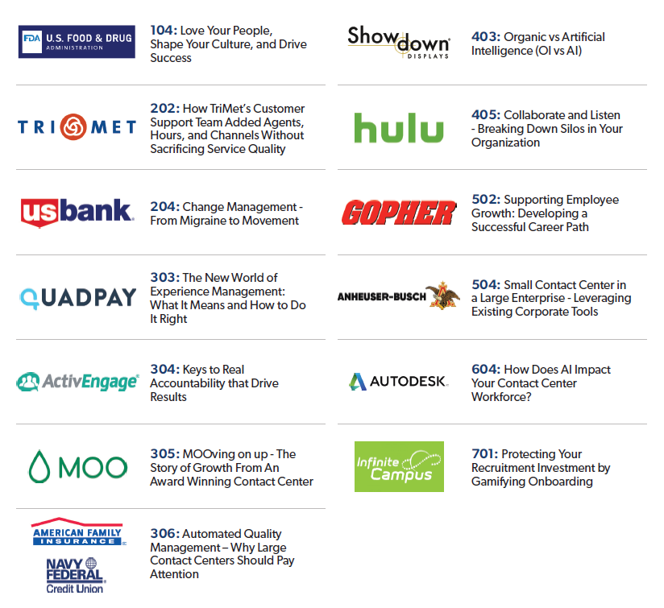

**LOCAL CX and CONTACT CENTER TOURS**

**Accelerate Access to Behind-the-Scenes Tours** *Requires a Pro Pass or All-Access Pass* [View Details >](http://www.icmi.com/Contact-Center-Expo-Conference/Program/Site-Tours)

|  |  |
| --- | --- |
| Related image | **CUSTOMER EXPERIENCE TOUR Amazon Fulfillment Center** This fascinating tour of Amazon’s state-of-the-art facility offers insight into how streamlining the delivery process improves overall customer experience.  **CUSTOMER EXPERIENCE TOUR Hard Rock Stadium, host venue of the 2020 Super Bowl!** Hard Rock Stadium is home to the Miami Dolphins, University of Miami, the Miami Open and host of the 2020 Super Bowl. This tour will take you through the stadium where you can see and learn firsthand how the Hard Rock Stadium team delivers exceptional service from the Guest Relations team to the Membership Experience team and beyond.  **CUSTOMER EXPERIENCE TOUR Carnival Cruise Lines** "The World's Most Popular Cruise Line®" with 26 ships operating 3- to 24-day voyages to The Bahamas, Caribbean, Mexican Riviera, Alaska, Hawaii, Canada, New England, Bermuda, Cuba, Europe, Australia, New Zealand, the Pacific Islands and Southeast Asia. The line currently has three new ships scheduled for delivery soon.  **CONTACT CENTER TOUR City Furniture** With 34 showrooms and an expansive e-commerce site, their team is comprised of over 130 remote and onsite agents and recent technology investments and strategies are focused on self service solutions to reduce call volume, agent UI optimizations in Salesforce to reduce AHT and increase productivity by creating a competitive team based production scoreboard. On this tour, the team will also discuss new hire training redesign that supports remote and onsite agents to allow for rapid growth without office expansion.  **SOCIAL MEDIA COMMAND CENTER TOUR NexGen** NexGen Agency's team manages the social engagement for multiple brands including Planet Fitness, Helzberg Diamonds and all the brands under Sound United. This 20,000 square foot facility includes over 150 workstations, training rooms, product labs, onsite café and a social media command center. The center is staffed with over 30 strategists who monitor in real-time, the social media channels and all channel support for their clients. You will see how the strategists are able to respond with the brand voice as they monitor the accounts with a wall of monitors. |

**EVENT SCHEDULE***Monday Workshops are included with Pro, All-Access and Deluxe Pass*

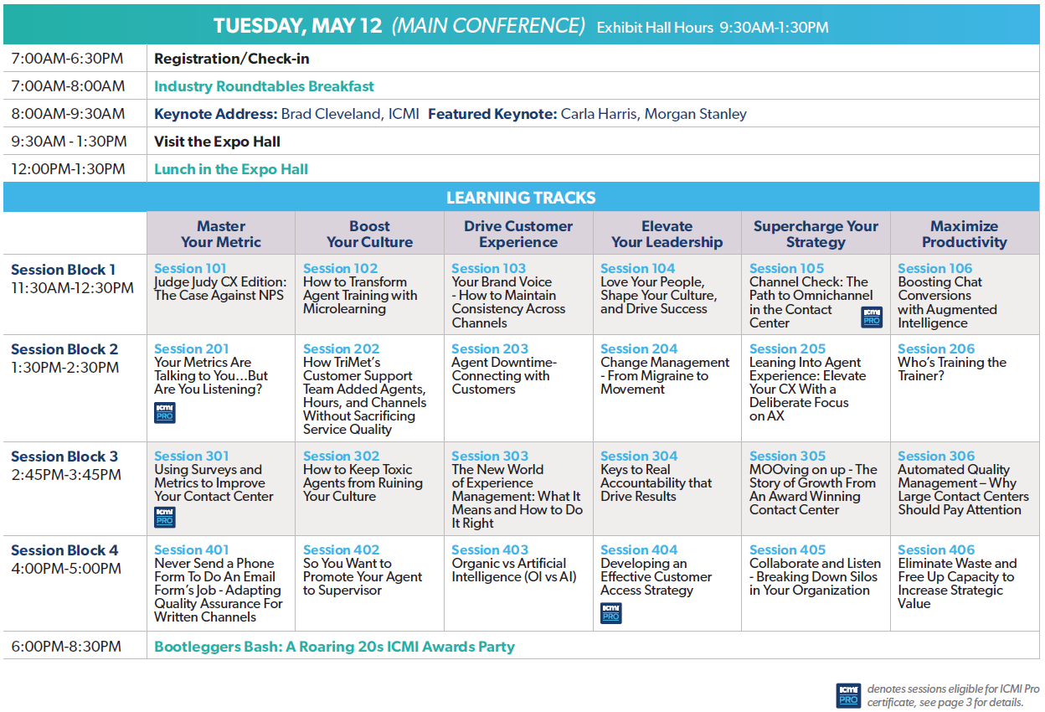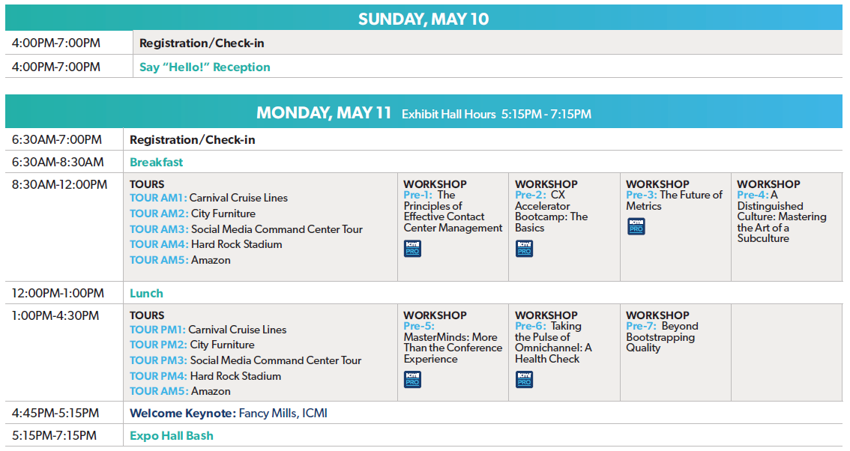*Tours are included only with the Pro and All-Access Pass*

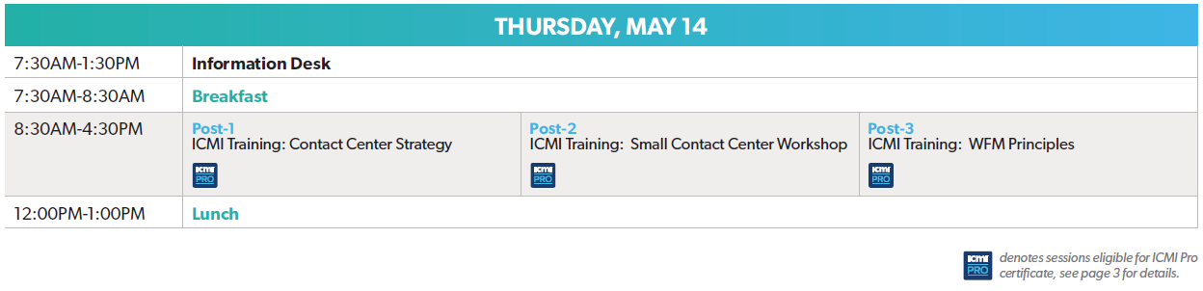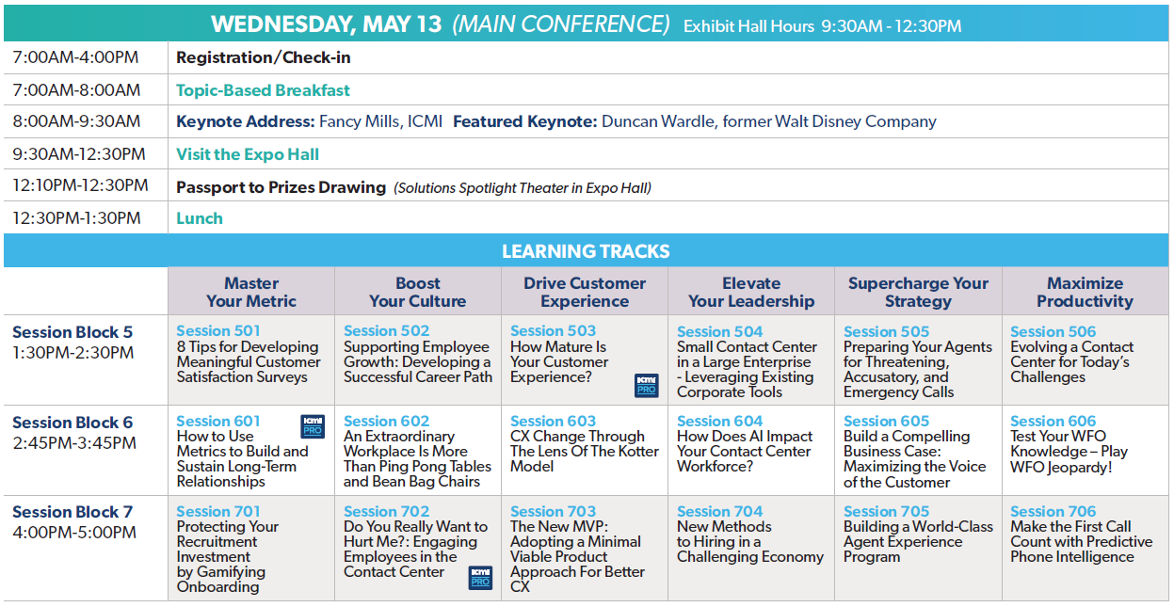

Link to: Download the [Printable Program Guide](https://www.icmi.com/Landings/Campaign/Event/Expo2020-Program-Download?s=cym)

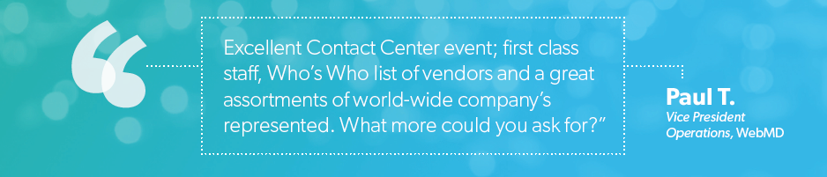 **What Other Industry Pros Are Saying About ICMI Contact Center Expo**

“This event is the best of the best!”

* **Cliff W., Call Center Manager, Vanderbilt University**

“If you have never been to a contact center conference this is the one to go to first.”

* **Ross A., Support Supervisor, Zonar Systems**

“ICMI [Expo] is one of the best! It finds the right balance of industry standards as well as brings new ideas and life into contact centers.”

**- Roger S., Sr. Operations Manager, Ancestry**

“ICMI Expo is an incredible opportunity to network and learn from industry peers.”

**- Alan S., Consultant Support Manager, Sentsy**

“ICMI provides me with motivation to come back and ignite my teams!”  
**- Susan D., Director, American Mint LLC**

“There are so many ways to do one thing and you can learn so much from others who take different approaches or think outside of the box. The information shared within each session is helpful and inspiring. The takeaway from this Expo is almost overwhelming!”

* **Sylvia T., Contact Center Supervisor, Lighthouse Central Florida**

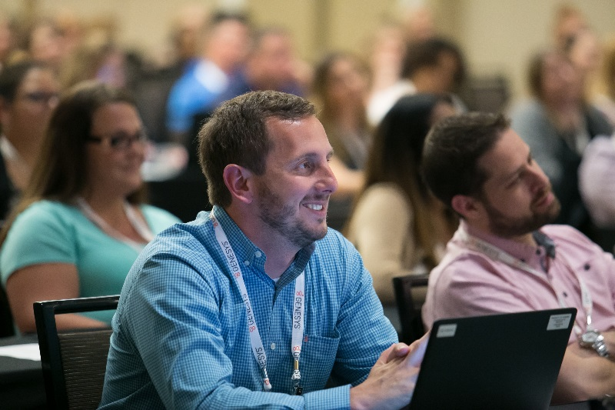

## Who Will I Meet at ICMI Contact Center Expo?

**Job Titles of Attendees Already Registered**

|  |  |
| --- | --- |
| * AVP, Contact Center * AVP of Customer Service * Call Center Manager * CEO * Client Service Manager * Contact Center Agent * Customer Care Manager * Customer Support Lead * Data Analytics Manager * Director of Customer Experience * Director * Manager, WFM, Planning and Strategy Managing Director, Customer Care | * Operations Manager Payments Servicing Manager President Project Manager * Quality Analyst * Senior Director, Enrollment Services * Sr. WFM Schedule Analyst * Supervisor * SVP, Client Services Training and Quality Manager * VP of Operations VP, Customer Service * Workforce Management Lead |

**Just a Small Sampling of Companies Currently Registered to Attend Expo 2020  
*Industries represented include: Financial, Insurance, Communication, Education, Utilities, Transportation, Government, Retail, Hospitality, and more.***

|  |  |
| --- | --- |
| AEFCU | Mayo Clinic |
| American Airlines Credit Union | Microsoft |
| Benjamin Moore & Co. | Northwestern Mutual |
| Best Western Hotel & Resorts | OE Federal Credit Union |
| Bluegrass Cellular | OneCause |
| Bristol Myers Squibb (Celgene) | Public Employees Health Program |
| Bryant & Stratton College | RBFCU |
| Cadillac Fairview | SafetyCall International LLC |
| Clark Public Utilities | SelectQuote |
| Columbia | SoCalGas Company |
| ComEd | Society of Petroleum Engineers |
| Delta Dental | TCM Bank |
| Desert Financial Credit union | Texas Association of School Boards |
| Florida Blue | TwinStar Credit Union |
| Gilsbar | UCHealth |
| Green Shield Canada | University of Pittsburgh |
| Hanover Insurance | Valero |
| Lincoln Heritage Life Insurance Company | Wright-Patt Credit Union |
|  |
|  |

**EXPENSES WORKSHEET**

Fill out this expenses worksheet to estimate the cost of attending ICMI Contact Center Expo.

***Note that the conference negotiated room rate for The Diplomat Beach Resort starts at $299/night.*** *There is also a $30 per night optional Resort Fee that includes 2 daily bottles of water and a daily group fitness class. Book by April 7, 2020.*

|  |  |
| --- | --- |
| ICMI Contact Center Expo  Registration  **Pass Options**  **Group Discounts** are off current pricing. The sooner you register the more you save!  **Team 3-5** Get 20% off  **Team 6-10**  Get 30% off  **Team 11+**  Get 40% off | **Select the pass that’s right for you!**    Learn more about ALL the benefits to the PRO Pass – visit [ICMI.com/propass](https://www.ICMI.com/propass)  Register with code **CYM250** and get an extra $250 off current pricing!  *Offer expires Friday, May 1. Promo code cannot be combined with other offers.* |
| Conf. Pass | $ |
| Air Fare + Luggage | $ |
| Parking & Tolls | $ |
| Mileage | $ |
| Hotel | $ |
| Taxi/Rental | $ |
| F&B | $ |
| **Estimate Total** | **$** |