Business Justification Toolkit
Everything You and Your Manager Need to Know

ICMI Contact Center Expo unites professionals looking to further their knowledge in an industry in constant transformation. As customer expectations continue to rise, it’s up to us—the contact center professionals—to rise with them.
So how can we keep up with rapidly emerging and evolving technologies? With heightened emphasis on meaningful metrics that drive change? With an increasingly diverse workforce? With all the pressure to create a flawless customer experience—through every interaction not only within our contact centers but across the entire organization?
Simple. We do it together at Contact Center Expo. Because that’s the only place you’ll be all in, linked by an unbreakable esprit de corps—unique in our profession of helpers and supporters. When we come together, whether it’s within our organization or outside, we strengthen our industry, our customer relationships, and ourselves.
We hope you and your team can join over a 1,500 other customer service professionals in Orlando, Florida. This year’s event offers 7 learning tracks, including one that addresses the unique needs of executive leadership.
This kit includes materials you can tailor to meet your needs and make things easier to organize a request for approval to attend and show ROI upon your return. It contains:
- A letter template
- Session tracks, Case studies, Tours
- Schedule at a Glance
- Track session summary
- What the media is saying
- Who attends Contact Center Expo
- An expense worksheet
With options of a 2-day, 3-day, 4-day or 4-day PLUS Pass, along with special pricing breaks and the special discount in this tool kit, we’re confident that you will find the right package to fit your budget.
We look forward to seeing you at the Walt Disney World Resort in Orlando this May!
Sincerely,
ICMI Events Team
P.S. Don't hesitate to reach out to us at icmiexporeg@ubm.com if we can provide any other information. You can also reach the team via Chat on ICMI.com/CCExpo

JUSTIFICATION LETTER TEMPLATE

Dear [Insert Approving Manager’s Name],
I am requesting approval to attend ICMI Contact Center Expo 2018, May 21-24 in Orlando. Contact Center Expo is organized by ICMI, a leader and trusted resource for contact center professionals for 32 years and in 2016 was featured on NBC Nightly News and in The New York Times. Their reputation is unmatched in the customer service/contact center industry.
ICMI Contact Center Expo is where contact center professionals find vendor-neutral education, the most credible speakers and the widest variety of case studies and behind-the-scene tours of local contact centers. It’s all developed by a team of objective practitioners and content professionals in the core areas needed to keep current on the skills and best practices required for our business.
The conference session tracks include:
- Achieve Metrics Nirvana
- Boost Your Culture
- Drive Customer Experience
- Elevate Your Leadership
- Maximize Productivity
- Optimize Technology
- Executive Perspectives – designed for Director level and above
Over the course of four days, Contact Center Expo offers hands-on workshops, exclusive tours of local contact centers, 60-minute main sessions, panel discussions, 27 case study presentations, and inspiring keynotes. I will also be able to interact directly with over 80 Exhibitors in the Expo Hall, which will allow me to personally test and evaluate a range of technologies and services that are important to our business.
When I return from Contact Center Expo, I will be able to share and suggest the latest trends and innovations with the rest of our organization. Contact Center Expo will also provide an opportunity for me to build a support system with other contact center professionals and learn from their experiences as they share success stories and lessons learned.
I've included a fact sheet for your review as well as a breakdown of the approximate cost of my attendance. You will find there are a number of different pricing options designed to fit our needs. With all of these opportunities to learn from industry leaders and connect with some of the top companies in the country, this conference has a strong ROI.
Please review these materials and let me know if you have any questions.
Sincerely,

[Signature]
LEARNING TRACKS

Unlike other conferences, at Contact Center Expo, you do not have to choose a track or pre-register for main sessions. Enjoy the flexibility of attending sessions across various tracks to create a customized experience that meets your needs.

Achieve Metrics Nirvana
Learn the latest approaches to analytics, customer effort measurement, ROI, big data, and communicating results. View sessions >

Boost Your Culture
Ideas to tackle the tough issues of hiring, mentoring, coaching, and motivating. View sessions >

Drive Customer Experience
The inside scoop on customer experience, surveys, loyalty, journey mapping, and customer satisfaction. View sessions >

Elevate Your Leadership
Best practices from industry frontrunners to help lead your team to success. View sessions >

Executive Perspectives
Gain unique and insightful perspectives from executives who share their experiences and challenges with culture, multiple centers, ROI and operational efficiency. View sessions >

Maximize Productivity
Critical insights and techniques into knowledge management, QA, workforce management, forecasting, and operational efficiency. View sessions >

Optimize Technology
Approaches to select and implement contact center solutions that will optimize performance. View sessions >

Case Study Presentations
Thirty-two world-class organizations, sharing ideas, best practices, and how they overcame common challenges
View Details >
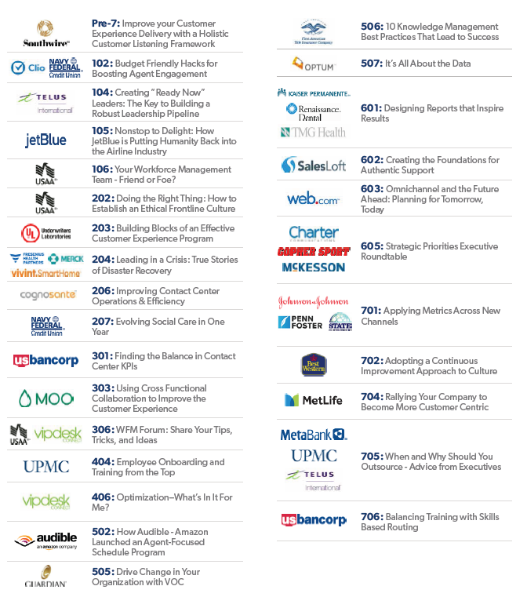

LOCAL CONTACT CENTER TOURS
Requires the 3-day or 4-Day Pass

View Details >

Exclusive Tour - New for 2018
Requires the 4-Day PLUS Pass

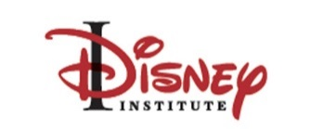
In this guided tour, participants will engage experienced Disney professionals and observe key examples from Disney's "living laboratory" theme parks, going behind the scenes to explore how Disney business insights and time-tested methodologies are operationalized to deliver a great customer experience. The tour shows how concepts from Disney Institute professional development courses come to life for Cast Members and Guests at Disney.

EVENT SCHEDULE
Monday Workshops and tours are included with 3-, 4-, and 4-day plus passes
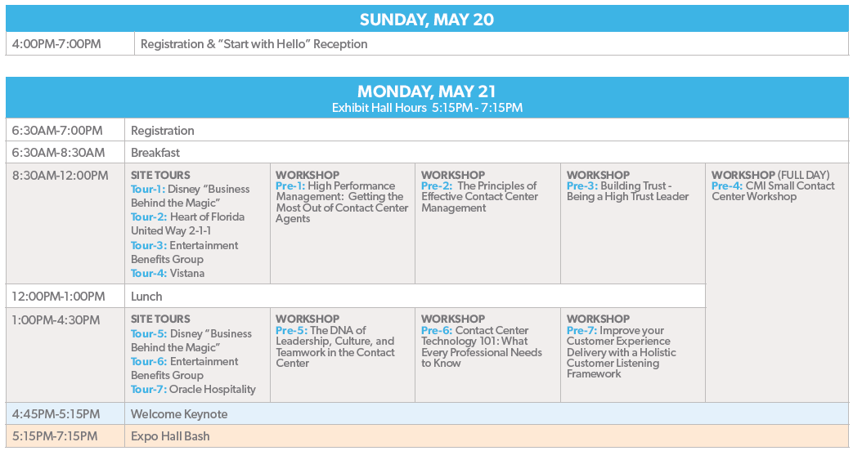

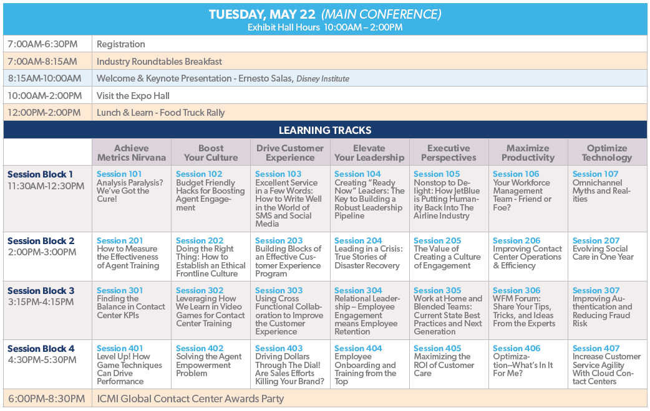
~ Schedule continued on next page ~
“

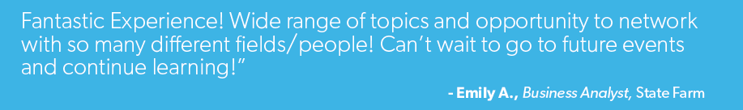
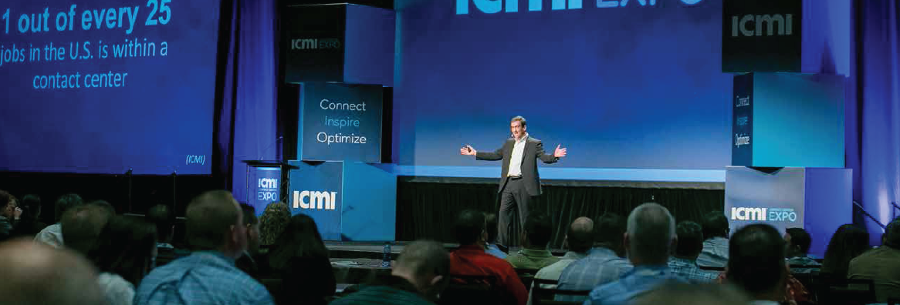

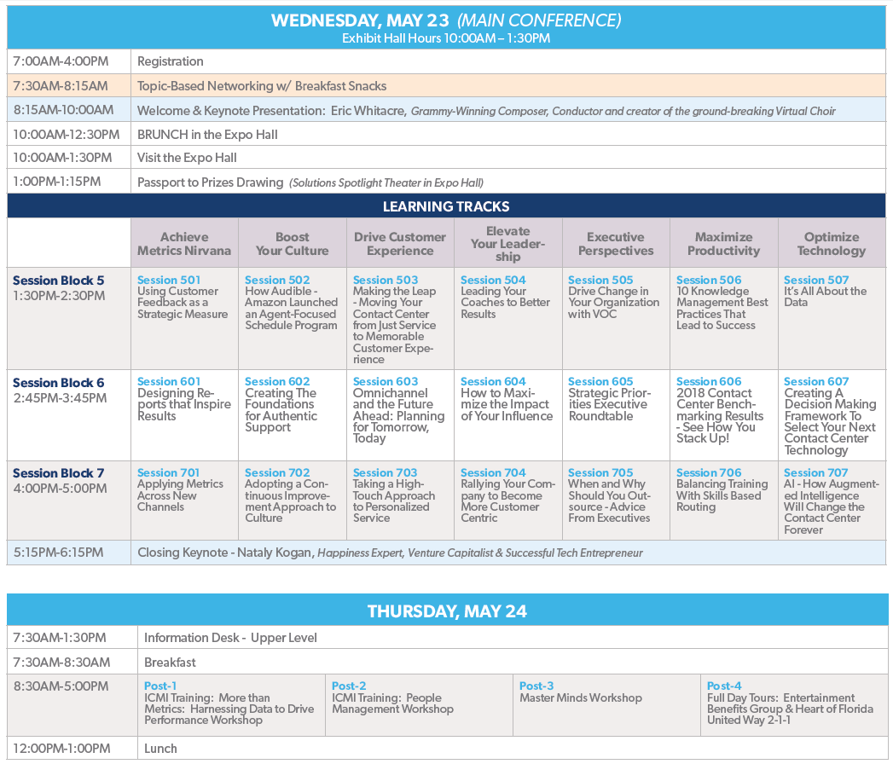

Link to: Full Conference Information
Link to: Program Brochure

What Other Industry Pros Are Saying About ICMI Contact Center Expo

“The tours, keynotes, sessions and expo hall were awesome. What a week!”
- Shakira P., Manager, Community Relations, Crisis Response Network

“Absolutely Amazing! You will not be disappointed!”
- Megan L., Guest Services Manager, The Henry Ford

“Best conference for contact center professionals, hands down.”
- Nate B., Director of Customer Experience, Underwriters Laboratory (UL)

ICMI highlights the importance of the service industry and brings thousands of like-minded professionals together. Having a platform to network and share stories is one of the best ways to learn and grow.
- Gina M., Manager, Support Services, Infinite Campus

“ICMI [Expo] is one of the best! It finds the right balance of industry standards as well as brings new ideas and life into contact centers.”
- Roger S., Sr. Operations Manager, Ancestry
“ICMI Expo is an incredible opportunity to network and learn from industry peers.”
- Alan S., Consultant Support Manager, Sentsy

“ICMI provides me with motivation to come back and ignite my teams!”
- Susan D., Director, American Mint LLC

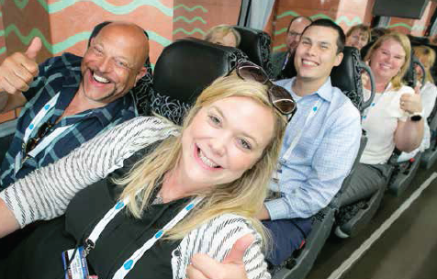

Who Will I Meet at ICMI Contact Center Expo?

Job Titles of Attendees Already Registered
- AVP, Customer Service  - VP, Enrollment Services  - Contact Center Manager  - Director, Call Center Operations  - Business Operations Manager  - CFO  - Customer Care Manager  - Director, Customer Service  - Associate Vice President  - Vice President, Customer Service  - Executive Vice President | - Senior VP, Support Services  - Sr. Workforce Management Analyst  - Supervisor of Operations  - VP, Member Care Center  - Workforce Manager  - Patient Services Director  - Assistant Manager, Customer Service  - Manager, Training & Development  - Quality Assurance & Training  - Senior Director, Contact Center  - Senior VP / COO

Just a Small Sampling of Companies Currently Registered to Attend Expo 2018
Industries represented include: Financial, Insurance, Communication, Education, Utilities, Transportation, Government, Retail, Hospitality, and more.
- American Eagle FCU | - MetLife
- American Public University System | - Moen
- Berkeley College/BES Inc.y | - Moo.com
- Booz Allen Hamilton | - National Guardian Life
- Bryn Mawr College | - Penn Foster
- Capital City Bank | - Peoples Bank
- Char-Broil | - Public Employees Health Program
- Chevron Products Company | - Spencer Gifts & Spirit Halloween
- Embrace Pet Insurance | - Sutter Health
- First National Bank and Trust | - TAL Healthcare
- Hanover Insurance | - The Hanover Insurance Group
- Hillsdale College | - Union Bank and Trust
- iStorage.com | - US Bancorp Fund Services
- Jockey International | - Walt Disney Parks & Resorts
- Kaiser Permanente | - Wine Country Gift Baskets
- Lincoln Heritage Life Insurance | - Wright-Patt Credit Union

EXPENSES WORKSHEET

Fill out this expenses worksheet to estimate the cost of attending ICMI Contact Center Expo.
Note that the conference negotiated room rate for the Walt Disney World Dolphin Resort starts at $225/night. There is also a $20 per day Resort Service Package fee plus applicable taxes.

ICMI Contact Center Expo  Registration  Pass Options  Conf. Pass | Select the pass that’s right for you!  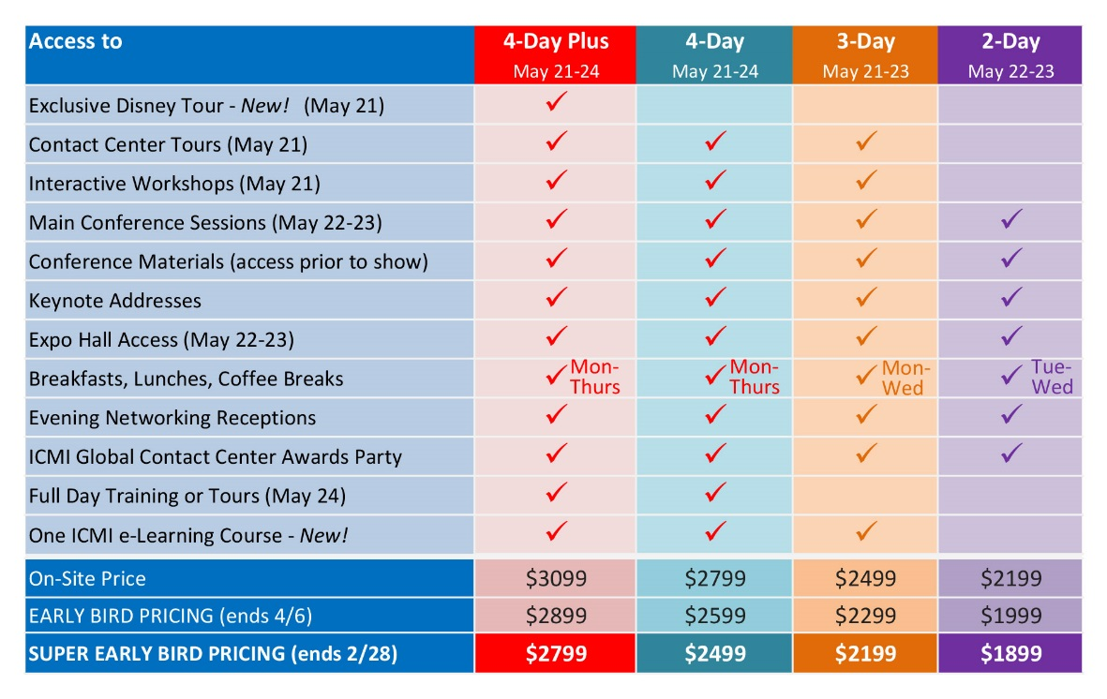  Register with code CYM and get an extra $100 off current pricing!  Offer expires April 6. Promo code is not applicable for the 4-day plus pass and cannot be combined with other promotional offers.  $
Flight + Luggage | $
Parking | $
Mileage | $
Hotel | $
Taxi | $
F&B | $
Total | $

