Contact Center Expo & Conference 2017 — Business Justification Toolkit

Everything You and Your Manager Need to Know
Over four days at ICMI Contact Center Expo & Conference, thousands of customer service professionals will discover the most current and cutting-edge technology innovations and strategies to drive their organizations' success in the areas of customer experience, workforce optimization, omnichannel best practices, metrics, employee engagement, and future trends in customer service.
We’re in a new era of customer experiences that’s placing demands on organizations like never before. For contact center leaders, the importance of leveraging the right technologies, delivering service in the most effective channels, and balancing people, processes, and automation is at an all-time high.
From the keynotes to the seven track topics to the events in the Expo Hall, you’ll learn the tips, tricks, and best practices that will get your company in front of the transformations taking place in the contact center industry and ensure that your organization delivers exceptional customer experiences in this complex and changing world.
We've included a few materials that you can tailor to meet your needs and make things easier for you to get approval to attend Contact Center Expo, including:
- A letter template
- Session track descriptions
- Schedule at a Glance
- Track session summary
- What the media is saying
- Who attends Contact Center Expo
- An expense worksheet
With multiple Conference pass options and special monthly pricing, we're confident that you will be able to find the right package to fit your budget.
We look forward to seeing you at the Walt Disney World® Resort near Orlando, FL this May 22-25!
Sincerely,
The Contact Center Expo Team

P.S. Don't hesitate to reach out to us at icmiexporeg@ubm.com if we can provide you with any other information.

JUSTIFICATION LETTER TEMPLATE

Dear [Insert Name],
I am requesting your approval to attend ICMI Contact Center Expo & Conference, May 22-25, 2017, in Orlando, FL. Now in its 14th year, Contact Center Expo is the only independent conference where contact center professionals find trusted education developed by a team of objective practitioners and content professionals in the core areas needed to keep current on the skills and best practices required for our business. Additionally, ICMI has been a leader and trusted resource for contact center professionals for 32 years and last year was featured on NBC Nightly News and in The New York Times.
The Conference session tracks include:
- Foundational Best Practices
- Future Trends in Customer Service
- Optimizing your Workforce
- Omnichannel Best Practices
- Contact Center Metrics
- Customer Experience
- Employee Engagement
Over the course of four days, Contact Center Expo offers full-day training, half-day hands-on workshops, exclusive tours of local contact centers, 60-minute main sessions, panel discussions, and inspiring keynotes. I will also be able to interact directly with over 100 Exhibitors in the Expo Hall, which will allow me to personally test and evaluate a range of technologies and services that are important to our business.
When I return from Contact Center Expo, I will be able to share and suggest the latest trends and innovations with the rest of our organization. Contact Center Expo will also provide an opportunity for me to network with other contact center professionals and learn from their experiences as they share success stories and lessons learned.
I've included a fact sheet for your review as well as a breakdown of the approximate cost of my attendance. You will find there are a number of different pricing options designed to fit our needs. With all of these opportunities to learn from industry leaders and connect with some of the top companies in the country, I hope you see the value of this event.
Please review these materials and let me know if you have any questions.
Sincerely,
[Signature]
SESSION TRACKS

Foundational Best Practices
New to your role in the contact center? We've emphasized the "how to" in these critical sessions so you can return home with actionable ideas for making immediate improvements in your contact center. Results are what you need, and this track will show you exactly how to achieve them in your own operation.
View Foundational Best Practices sessions >

Future Trends in Customer Service
Is your contact center prepared to meet the needs of tomorrow’s customers and employees? We’ve identified several trends to watch as expectations shift and technology evolves. This track will explore developments shaping both customer and agent expectations, as well as examine the role emerging technology will play in the continued evolution of customer service.
View Future Trends in Customer Service >

Optimizing Your Workforce
This track will show you how workforce optimization can positively impact both the contact center and the business as a whole. You’ll walk away with actionable insight you can use to better manage onboarding and ongoing training, forecasting, scheduling, work from home agents, distributed workforces, and more. These sessions will enable you to drive increased productivity and efficiency in your center.
View Optimizing Your Workforce sessions >

Omnichannel Best Practices
Your customers expect service options in the channel of their choice, and at a time that’s most convenient for them. If you’re looking for insight to help you determine the right channel mix and learn how to deliver a seamless cross-channel experience, this is the track for you. We’ll explore the strategy, processes, and technology needed to deliver best in class omnichannel service.
View Omnichannel Best Practices sessions >

Contact Center Metrics
There’s no shortage of data in the contact center, but determining what to measure and how to interpret the data to drive meaningful results can be a challenge. This track will provide you with the research, benchmarks, best practices and case studies needed to implement metrics that improve operations.
View Contact Center Metrics sessions >

Customer Experience
As customer touch points increase, the contact center is quickly becoming the epicenter for how customers perceive their interaction with your company. This newly created track address the challenges, successes and roadmaps needed to improve your customers' experience.
View Customer Experience sessions >

Employee Engagement
If you're responsible for managing people in the contact center, this track is where you'll find the ideas and resources you need to improve. We'll tackle the tough issues of retention, coaching, stress, and attendance, and explore career pathing and the needs of the next generation. This track will arm you with innovative strategies to manage change.
View Employee Engagement sessions >

EVENT SCHEDULE
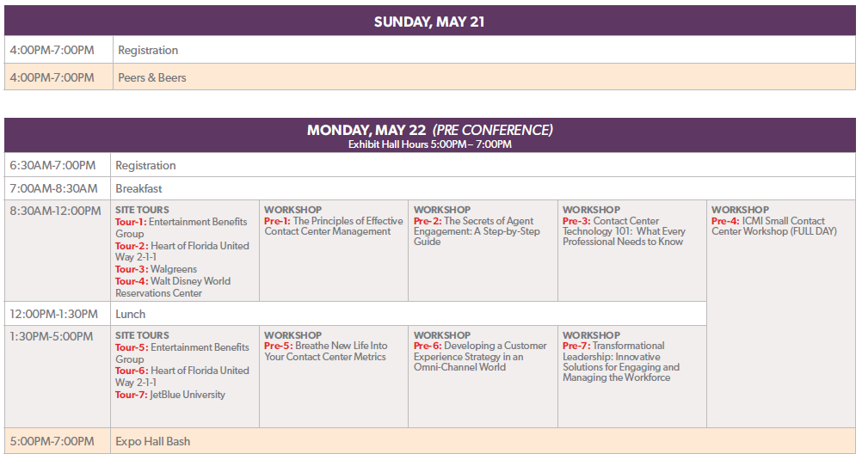
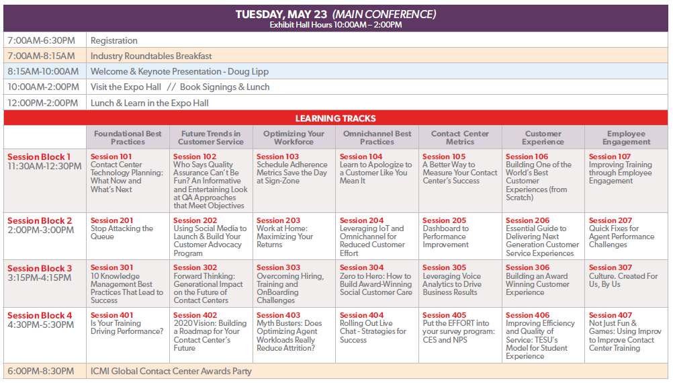

EVENT SCHEDULE, Continued
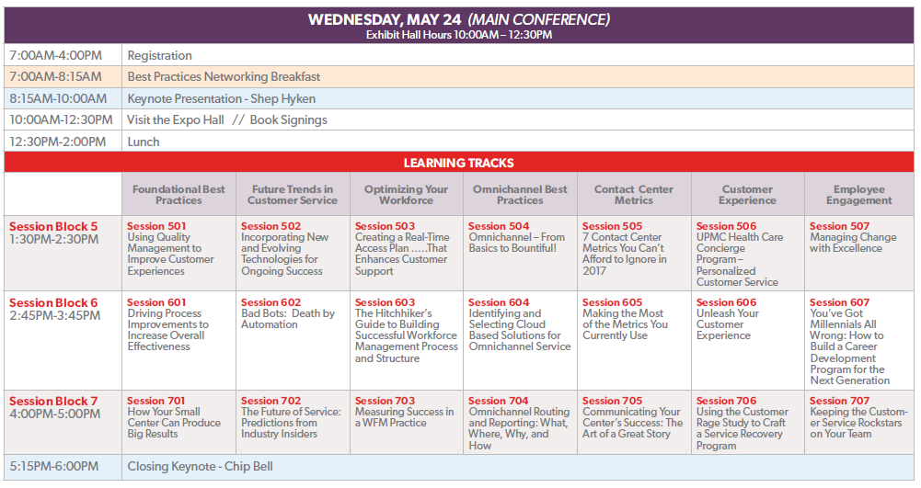
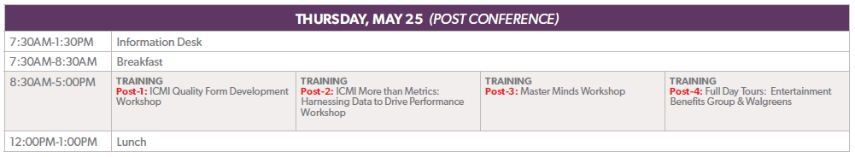

Link to: Full Conference Information
Link to: Program Brochure

What Other Industry Pros Are Saying about ICMI Contact Center Expo & Conference
“The conference was well organized and provided a variety of training sessions that I found very valuable. I enjoyed the keynote speakers, as well as being able to discuss best practices with my peers from other call centers." — Sherri B., Quality Manager, OptumRx
“This was my third straight year attending and I've come away with pages of notes to share with my team when I return. I get so much from the sessions and contact center tours that all the other stuff feels like a bonus.” — Nicholas W., Director of Customer Service, National Guardian Life Insurance.
“The opportunity to learn from others is invaluable. There are so many companies represented, that we are able to learn from each other without worrying about giving away trade secrets! Being able to see how others use their technology is a huge plus- it's nice to hear the challenges others have faced and the creative ways they used the technology.” — Lindsey W., Call Center Manager, Pepsi Bottling Venture
“This conference was a game changer for me. There were so many concepts around metrics and coaching that we have been trying to implement, and those same concepts were discussed here. I was able to take what we have already done, mix in some of these amazing ideas from the conference, and build something that will totally change our contact center for the better!” — Haley B., Sponsor and Donor Relations Operations Analyst, Compassion International
“I learned so much and I have come back to my contact center with new enthusiasm and great ideas for improvement.” — Lonnie G., Contact Center Director, Progressive Finance
“This was my first ICMI conference and I was very impressed with this event. The keynotes were relevant and amazing; the venue was well organized and used very well; the sessions were valuable not only from content but from crowd participation. I couldn't have picked a better conference to attend for my first contact center conference.” — Matthew B., Senior Manager Customer Care, Technology Services, J. J. Keller & Associates
“Having interaction from each of the participants in the sessions was very helpful. That gave ideas on what has worked, and what hasn't, in other people experience. Real life examples are huge in these conferences.” — Zach G., Customer Service Supervisor, National Guardian Life Insurance
“The Opening sessions and the general sessions add so much value. There was a lot of very great topics to pick from. I walked away with a wealth of information.” — Julie S., Senior Director Support Services, Wolters Kluwer
“I really enjoyed the small contact center workshop. It was very informative, and the way that it was set up, really allowed me to interact with other people with similar issues and circumstances.” — Conrad B., Familia Contact Center Manager, Bank of Guam

Who Will I Meet at ICMI Contact Center Expo & Conference?

Sample Job Titles of Attendees Currently Registered
- Contact Center Manager  - Director, Call Center Operations  - Senior Director  - Associate Vice President  - Vice President, Customer Service  - EVP / Senior VP  - Director, CIS  - Information Services  - Manager, Training & Development  - Quality Assurance & Training | - Workforce Management  - Training Manager  - Supervisor, Customer Service  - Team Lead  - Senior Manager, Customer Care  - Quality Analyst Training Manager  - Technical Support / Service Desk  - Director, IT Services  - Manager, Social Care Team  - Member Services Manager

Sample Companies of Past and Currently Registered Attendees
Industries represented include: Financial, Insurance, Communication, Education, Utilities, Transportation, Government, Retail, Hospitality, and more
- AARP | - Progressive Insurance
- Alarm.com | - Sign Zone
- Allstate | - Spencer Gifts
- Amazon Web Services | - State Fund of California
- American Honda Finance | - Symantec
- Blue Cross Blue Shield | - TD Ameritrade
- Caliber Home Loans | - Texas Dept of Public Safety
- City of Atlanta | - The Home Depot
- Colorado 811 | - Thomas Edison State College
- Costco | - Thomson Reuters
- First National Bank | - Uline
- Hallmark | - UMB Bank
- Kaiser Permanente | - USDA
- Midcontinent Communications | - Vanguard
- Moen | - VF Imagewear
- National Guardian Life Insurance | - Walmart
- Navy Federal Credit Union | - Web.com
- Northwestern Mutual | - Wells Fargo

EXPENSES WORKSHEET

Please fill out this expenses worksheet to estimate the cost of attending ICMI Contact Center Expo & Conference 2017.
Note that the Contact Center Expo attendee negotiated room rate for the Walt Disney World® Dolphin and Swan Resort is $219/night for a standard room plus taxes and a $20/night resort fee if you book by April 27, 2017 (space available – book early!)

ICMI Contact Center Expo & Conference  Registration  Pass Options*  *Check website for current pricing that includes monthly discounts  Conf. Pass | Select the pass that fit your needs:  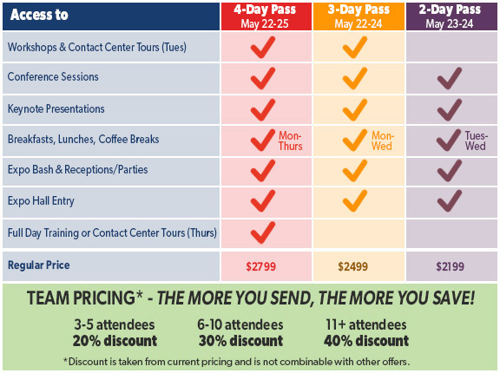  $
Flight | $
Transportation | $
Mileage reimbursement | $
Lodging | $
Food per diem | $
Total | $

